Tristan Morse

Professor Judy Beck

29 April 2017

PHYS 131

Inquire Final Product

1. Title
   1. Angular Acceleration of a Hard Disk Drive Platter
2. Description of Observation
   1. For some time now, I’ve been trying to get really into technology, especially with computers regarding their software and hardware. Because of this interest, I naturally felt the inclination to major in computer science and minor in new media at UNC Asheville. Since I’m going to be delving deeper into this field, I wanted to learn more about what I don’t know too much about: the hardware side of computers. This summer, I will be making a custom PC to use throughout college and beyond, as I will upgrade it as the years go on. Besides having to figure out how to assemble it all, I was actually wondering about some specific aspects of some of the parts in relation to physics. More specifically, I’m going to be installing a couple “hard disk drives” or “HDD’s,” as shown in figure 1, which are parts that the computer stores information onto magnetically, retaining the information even after someone where to turn off their computer. There are usually several metal disks inside, giving it its name, which are known as “platters” which are spun around at a certain RPM by the “spindle.” The disks are manipulated by the “heads” on the “actuator arms,” which are controlled by the “actuator.” The head uses magnetic currents to encode binary signals, creating the storage of data values that the computer understands. With a HDD, I was wondering what its angular acceleration would be in a certain time interval of about 3.0 seconds.
3. Visual

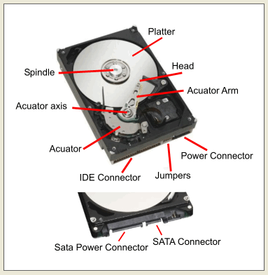

*Figure 1: The internals of a Hard Disk Drive (*<https://goo.gl/WVqU1X>*)*

1. Physics at work
   1. Rotational kinematics
2. Inquire
   1. What is the angular acceleration of one of the platters in my hard disk drive in the time interval of 3.0 seconds?
3. Approach
   1. My approach to the problem was to convert the RPM of the HDD to rad/s so then I could get the angular velocity, as hard disk drives usually display their speeds in RPM. From there, I would be able to plug it into the equation for angular acceleration and use the given time interval of 3.0 s. Finally, I would get the answer for what the angular acceleration of a hard disk drive platter is within 3.0 s.
4. Data and Assumptions
   1. RPM of HDD is 7200RPM
   2. Time interval of 3.0 seconds
   3. HDD doesn’t catch on anything
   4. HDD is working properly
5. Solution

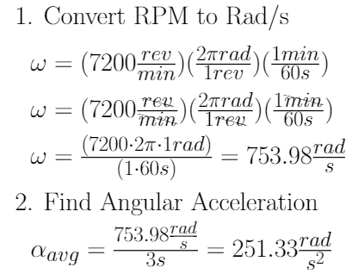

1. Reflection
   1. After solving this problem, I felt that it was relatively easy. If I were to ask my high school self who was in a high school physics to solve this problem, I probably wouldn’t of been able to do it. Since I have taken this class though, I have gotten a better understanding of physics, so it made solving this problem a lot easier. It took me a little while to figure out a proper way to go about this problem due to the fact that I didn’t convert my units properly, so it skewed my initial results and thought process. I feel like the final answer that I got is reasonable, as the angular acceleration decreases as the time interval increases, as the angular velocity becomes closer to being constant as time progresses. This is what is supposed to happen, so it makes sense that the math works out that way. With that, I’d say I’m fairly confident in the answer I came up with.
2. Overall Assessment and Reflection
   1. I thought that this helped me better understand the practical applications of physics as well as get more comfortable with the concepts. I had to think critically to come up with a problem and had to solve one to find out the answer to it. I think that this sort of process is very applicable to any question I may ever want to ask and find out about physics in any situation. I am also happy that it gave me an excuse to use the programming language “LaTeX” more, as I find it a useful tool to format my mathematical equations and to make my scientific papers look nice (and to format the math equations in our own textbook!). I enjoyed this process and I am glad that I gained a lot of experience from it.